PROVISIONAL MARKING KEY

2026 SEED CHEMISTRY PAPER I

SECTION A (70 marks)

1a. Explain why bond breaking is endothermic and bond making is exothermic.
Bond breaking requires energy from the surrounding to overcome forces between atoms, so it is endothermic /1 while bond making releases energy to the surrounding when atoms form
stable bonds, so it is exothermic. /1 (2 marks)
b. State any two importance of endothermic reactions in everyday life.
i. Cold packs for sports injuries ii. Thermal cracking of hydrocarbons
iii. Photosynthesis (any two, 1 mark each )
2a. Define a polymer.
A polymer is a long-chain molecules which is formed when small molecules join together.
(1 mark)
b. Figure 1. shows polymerisation process of one of the monomers.
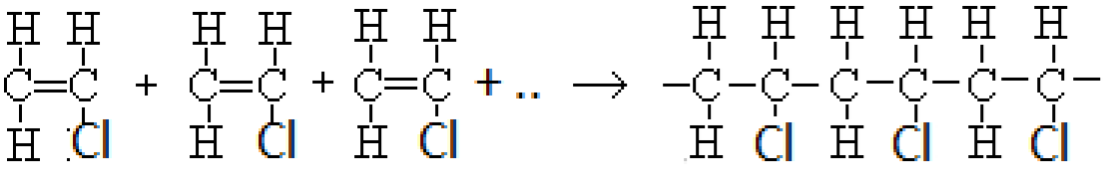
- Name the type of polymerisation shown by the reaction above.
Addition polymerisation (1 mark)
- Name the polymer formed in 2b. above.
Polychloroethene or polyvinylchloride (1 mark)
- Describe how the polymer mentioned in 2b (ii) is formed.
During polymerisation of chloroethene, the double bond between the carbon atoms is broken down/ 1 enabling many molecules of chloroethene to join to each other to form a large molecule
called polychloroethene / 1 (2 marks)
3a. Figure 2 shows allotropes of carbon labelled P and Q.
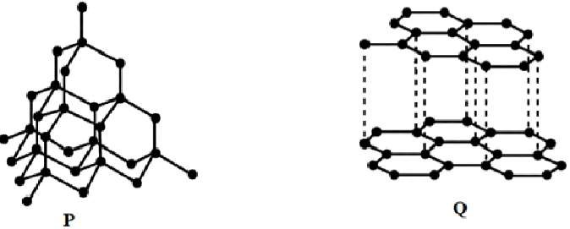

i, Identify the allotrope that conducts electricity.
Q (Graphite) (1 mark)
ii, Which allotrope is used to make surgery instruments?
P (Diamond) (1 mark)
iii, Explain why the allotrope mentioned in 3 a (ii) is used to make surgery instruments.
- Diamond is extremely hard.
- It resists wear and maintains sharp edges. (any one, 1 mark)

b. Explain why ionic compounds conduct electricity in molten state and not in solid state. This is because in molten state, the ions in ionic compounds are free to move and carry with them electric charge hence conducting electricity, / 1 while in solid state, their ions are not able to move
freely. 1 (2 marks) c. State any one uses of Perspex.
- It is used as glass substitute.
- It is used as lense (any one,1 mark)
4a. Define oxidation in terms of electron transfer.
Oxidation is the loss of electrons. (1 mark)
b. The electrode potential of copper and iron are as given below:
Fe²⁺ _{(aq)} + 2e⁻ Fe _{(s)} ; E⁰ = - 0.44V
Cu²⁺ _{(aq)} + 2e⁻ Cu _{(s)} ; E⁰ = +0.34V
Find the e.m.f of the cell obtained when copper and iron are combined.
E0cell = E0RHS electrode – E0LHS electrode 1
E°cell = +0.34 − (−0.44) = 0.78 V
1 1 (3marks) c. State any one use of propanone.
- It is used as a solvent for both polar and non-polar covalent substances, plastics and synthetic fibres, glasses jewelry etc
- It is a nail vanish remover. (any one, 1 mark) d. Define an alloy.
An alloy is a mixture of more than one metal or a metal and a non – metal. (1 mark) e, Which alloy is used to manufacture airplane parts?
Duralumin (1 mark)
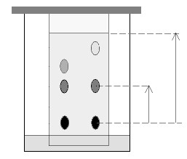
5. Figure 3 is a diagram showing chromatography process of ink spots X and Y. 4cm component ink spot X Y

distance travelled by

solvent

chromat
ograms

R

10
cm

P

M N

distance travelled by

solvent base line

a, Which two components are absorbed more strongly by the stationery phase?
M and N
1 1 (2 marks) b.i, Which component is most soluble in the solvent?
R (1 mark) ii, Give a reason for the answer in 2b.i. above.
Because it has travelled faster and reached the maximum height compared to the other components.
(1 mark)
c. Calculate the relative flow value for component M.
Relative flow value = distance travelled by a component 1 distance travelled by solvent
= 3cm 1
8cm
= 0.375 1 (3 marks)
6, Methane (CH₄) react completely with oxygen (O₂) to produce carbon dioxide and water.
- Write a balanced chemical equation for the reaction.
CH₄(g) + 2O₂(g) → CO₂(g) + 2H₂O(l)
(2 marks)
- If 3.2g of methane reacted with oxygen, how much carbon dioxide was produced?
(RAM: C= 12, H = 1, O = 16).
From the balanced chemical equation,
16g of methane produced 44g of carbon dioxide. 1
⸫ 3.2g of methane will produce: 3.2g x 44g /1 = 8.8g 1
16g (3 marks)
- Calculate the volume of oxygen required to burn 3.2g of methane completely at room temperature and pressure? (Molar volume at r.t.p = 24dm³).
From the balanced chemical equation,
16g of methane reacts with 64g of oxygen.
⸫ 3.2g of methane requires: 3.2g x 64g / 1 = 12.8g = 0.4 moles of oxygen 1
16g
But 1 mol of oxygen gas occupies 24dm³
⸫ 0.4moles = less
= 0.4mol x 24dm³ /1 = 9.6 dm³ 1
1 mol (4 marks)
7a. Define water pollution.
It is the addition of harmful substances into water as a result of human activities.
Or
It is any change in the quality of water that has harmful effects on any living organism that uses
the water. (1 mark) b. State any two pollutants of water.
Human feaces and sewage, effluents (liquid wastes), pesticides, herbicides, weedicides and
fertilizers. (any two, 1 mark each
(2 marks)
c, Mention any two health benefits of hard water?
- Calcium ions present in hard water are required by the body for bones and teeth.
- Coates lead pipes with a thin layer of lead sulphate or lead carbonate and prevents the lead from dissolving in water. iii. It is good for the formation of shells in animals.
iv. Calcium and magnesium present in hard water are necessary for growth of both plants
and animals. (any two, 1 mark each)
d, State any one advantage of “reduction at source” as one way of minimizing wastes. i. It is cheap
ii. It reduces amount of items that can be wasted. (any one, 1 mark)

8a. What is meant by “empirical formula of a compound”?
It is the formula that shows the simplest whole-number ratio of atoms of each element in a
compound. (1 mark)
b. Work out the empirical formula of a compound that has the following percentage composition by mass of elements: C = 40%, H=6.67%, and O = 53.33%. (RAM C = 12, H = 1, O = 16)
Number of moles of each element:
C: 40 ÷ 12 = 3.33 1
H: 6.67 ÷ 1 = 6.67 1
O: 53.33 ÷ 16 = 3.33 1
⸫Simplest mole ratio = 3.33 : 6.67 : 3.33 1
3.33 3.33 3.33
Mole Ratio = 1: 2: 1 1
⸫ Empirical formula is CH₂O 1 (6 marks)
c, State any two uses of phosphoric acid.
  - Production of fertilizer.
  - Used as an electrolyte in fuel cells iii. Used by dentists as an etching solution to clean and roughen teeth surfaces.
  - Used as cleaning agents, to remove mineral deposists, cement smears and hard water stains.
  - For rust removal and metal treatment. vi. Used in food and beverage industry as acidulant to provide sour flavor.
(any two 1 mark each)
9a. 4. Below are condensed formulae of some organic compounds.
  - CH₃CH₂COCH(CH₃)CH₃
  - CH₃CH₂CH(CH₃)CH₂COOH
  - CH₃CH₂CH₂CHO D. CH₃CH₂CHOHCH₂CH₃
  - Name organic compounds A and B.
A: 2 - methyl pentan-3-one (1 mark)
B: 3 - methyl pentanoic acd (1 mark)
  - Write the structural formula of a compound which is a conformer to organic compound C.
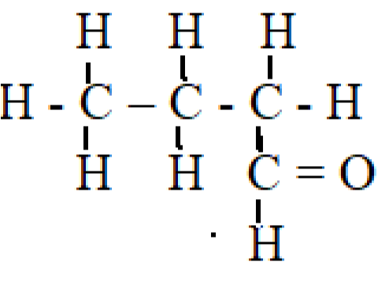 (1 mark)
(and other structures which will form a straight chain)

  - Which organic compound can react with compound B to produce an ester.
D (1 mark)

d. Which organic compounds can give positive results with Tollens test.
C (1 mark)
e. Write the products of the following chemical equation.

2 C₂H₅OH(l) + 2 Na(s) → 2 C₂H₅ONa(aq) + H₂(g) (3 marks)
1 1 1

10a. Figure 4. Shows a graph of volume of gas collected against time for the reaction of magnesium with hydrochloric acid at a certain concentration.
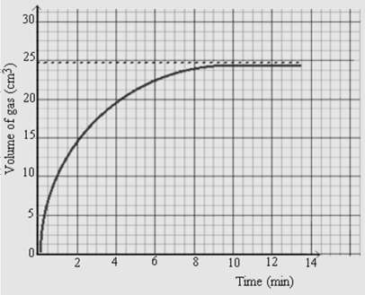

Figure 4. Graph for the reaction of magnesium and hydrochloric acid against time.
- What was the maximum volume of the gas collected from the reaction?
Maximum gas collected is 24.375cm³ (1 mark)
- After how many minutes did the reaction stop?
9 minutes (1 mark)
iii, Calculate the rate of reaction between 1 and 3 minutes?
After 1 minute, volume of gas produced = 10cm3 1
After 3 minutes, volume of gas produced = 17.5cm3 1
⸫ Volume of gas produced between 1 and 3 minutes = 17.5cm³ -10cm³
= 7.5cm³ 1
⸫ Rate of reaction between 1 and 3 minutes = 7.5cm³ = 7.5cm³ 1
3-1 2minutes
= 3.75cm³/min 1 (5 marks)

b, Explain how burning of fuels causes global warming.
Burning of fuels produces carbon dioxide (CO₂) /1 which traps heat in the atmosphere and increases global temperatures. 1
(2 marks)
SECTION B (30 marks)
11a. Describe how deforestation increases the concentration of carbon dioxide in the atmosphere.
During deforestation, there is permanent removal of trees, forests and through cutting and burning forests. /1 This destruction of living trees reduces amount of photosynthesis /1 which removes carbon dioxide from the atmosphere. /1
In addition to this, trees that are cut release carbon dioxide into the atmosphere /1 when they are decaying. /1 This also lead to an increase in the concentration of carbon dioxide in the atmosphere.
b. Describe how nitrogen is isolated from air in the laboratory.
- Air is passed through the filters where it is purified. 1
- Air is then forced out of the aspirator / 1 by passing a stream of tap water slowly into the aspirator. 1
- Then it is passed into the wash bottle containing potassium hydroxide solution which reacts with carbon dioxide. 1
- Air is passed through the hot copper turnings where oxygen is removed. /1 Then nitrogen is passed through delivery tube and is collected in the gas jar.
(4 marks)

12. With the aid of a well labelled diagram, describe how copper can be refined using electrolysis process.

. a. Set up the apparatus as shown in figure below
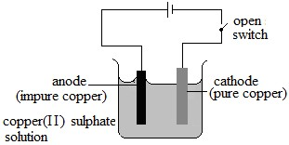

cell

1

mark for correct diagram

1

mark for any two correct

labelling

- Close the switch. (1)
- At the anode
The impure copper dissolves (1) where the copper atoms lose electrons and enter into the solution as ions. (1) The half equation for the reaction at the anode is: Cu (s) → Cu²⁺ (aq) + 2e⁻ (1) d. At the cathode
The positively charged (Cu²⁺) ions are attracted to the cathode (1) and get discharged by accepting two electrons (1) as shown by the half equation:
Cu²⁺ (aq) + 2e⁻ → Cu (s) (1)
Then the pure copper atoms produced are deposited at the cathode (1) and sludge from impure copper drops at the bottom of the beaker.

13. In a laboratory, labels fell off from the bottles containing an alkane, alkene, alkanol and alkanoic acid. Describe an experiment that could be done to identify the contents of the bottle.
- Solubility test
- Put 15 drops of distilled water in different test tubes. 1
- Add 2 – 3 drops of unknown substance to the test tubes containing water and shake well. 1
- The substances which produces two layers arealkanoic aci and alkanol while the one that will produce one layer are alkane and alkene. 1

- Acid test
  - Put 10 drops of sodium hydroxide (NaOH) in two different test tubes. 1
  - Add 2 – 3 drops of phenolphthalein indicator. 1
  - Then, add 15 drops of the soluble unknown substances in separate test tubes containing the pink solution and shake gently. 1
  - The substance that will decolourise the pink solution is an alkanoic acid while the one that will not decolourise the pink solution is an alkanol. 1
- Bromine test
    - Put 10 drops of bromine solution in two different test tubes. 1
    - Add 2 – 3 drops of the insoluble unknown substances to the bromine solution in separate beakers. 1
    - The substance that will change the brown colour of bromine solution to colourless is an alkene while the one that will not change the brown colour of bromine solution is an alkane. 1
(10 marks)

END OF PROVISIONAL MARKING KEY

